Meeting to discuss the possible installation of RF fingers in the LHC TDIs
(on 27/09/06 in the CCC)

Present: Oliver Aberle (AB/ATB), Fritz Caspers (AB/RF), Alexej Grudiev (AB/RF), Vincent Maire (TS/MME), Elias Metral (AB/ABP), Mike Owen (AB/ATB).

- There is a (longitudinal) 1 mm gap (all along the TDI) between the absorber and the beam screen. This gap has to be kept as it is through this gap that the HOMs can be damped with ferrites which should not be seen by the beam and which will therefore be put “outside” (i.e. behind this gap). One has to keep in mind that this will increase the transverse broad-band impedance, but there is no other solution if we want to put ferrite.
- The purpose of today’s meeting was to speak about the other gaps => 7 gaps of 5 mm (between the 8 modules) + 12 gaps of 0 mm (i.e. touching gaps) between the blocks. Gaps at the entrance and exit have already been discussed (between Vincent and Alexej) and RF fingers are already foreseen.
- It was agreed that some metallic coating on the front and end faces + a rounding of the edges (removing ~ 2 mm of material) + an ondulated (to have an elastically closed contact) foil (in copper-beryllium) whose thickness could be ~ 0.5 mm and which could be put in all the gaps (2 or 3 mm retracted from the beam) should help.
- The presently built "first version" without ferrites and RF fingers will be installed in next week in LSS8R (and then removed after the 450 GeV "engineering run" and will be reworked as a common spare for IR 2 and 8).
- Both ferrites and RF fingers should be installed in the next TDI which will be installed in LSS2L in early 2007.
- Some questions arose during the meeting and are put as actions for the next meeting (foreseen in ~ 2 weeks).
- Actions:
- Understand why a coating in Ti (whose resistivity is 5810⁻⁸ m, i.e. ~ 30 times higher than Cu, whose resistivity is 1710⁻⁹ m) has been foreseen on the HBN. Can’t we put Cu?
- Check that the beam losses (which are believed to be the dominant heating mechanism) do not heat the foil too much.
- Find a way to round the edges of the HBN.
- Choose the best method of metallization. Why not make a metallization everywhere, putting the TDI in a bath…?
- If all this is OK, then Fritz will provide the ondulated foils (Fritz will order them in the industry, where he already has a lot of experience with these kinds of foils).
- Some pictures sent by Vincent after the meeting:
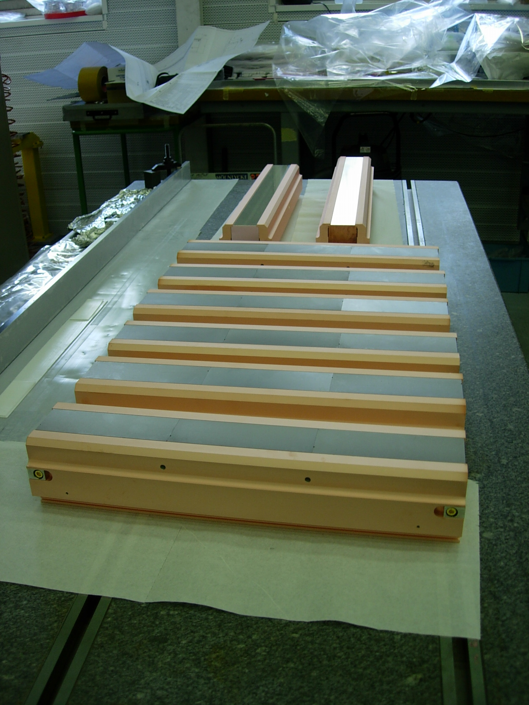
Fig.1: Ensemble.

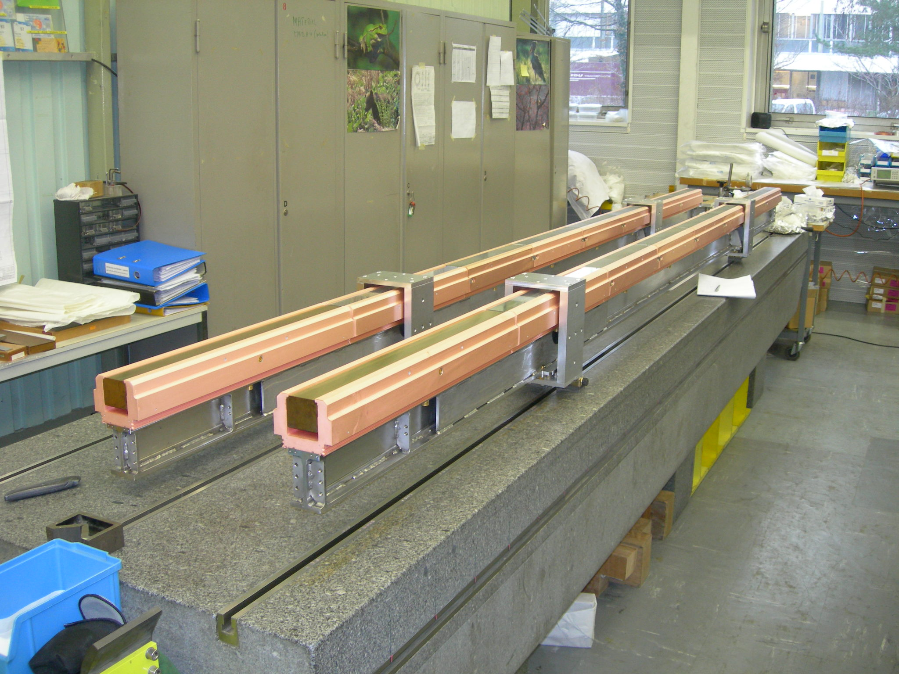 Fig.2: DSCN0178.

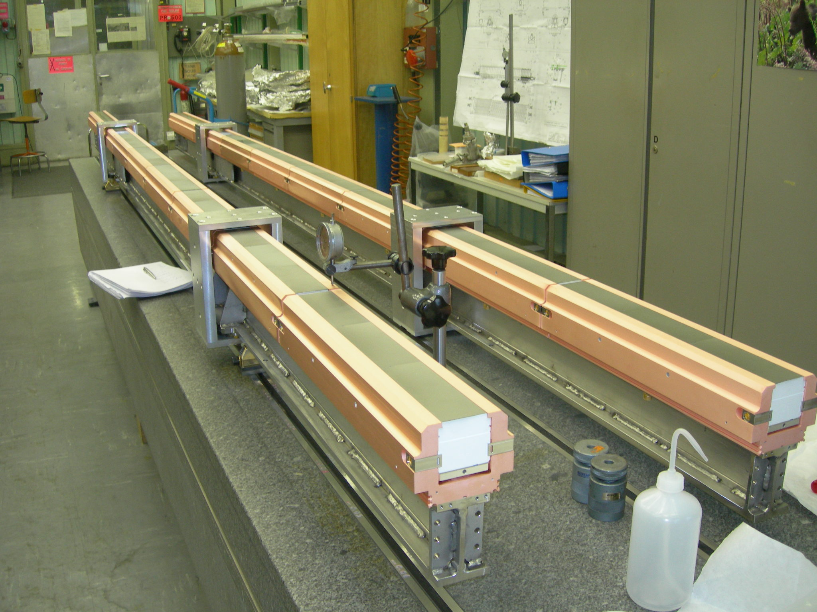
Fig. 3: DSCN0179.

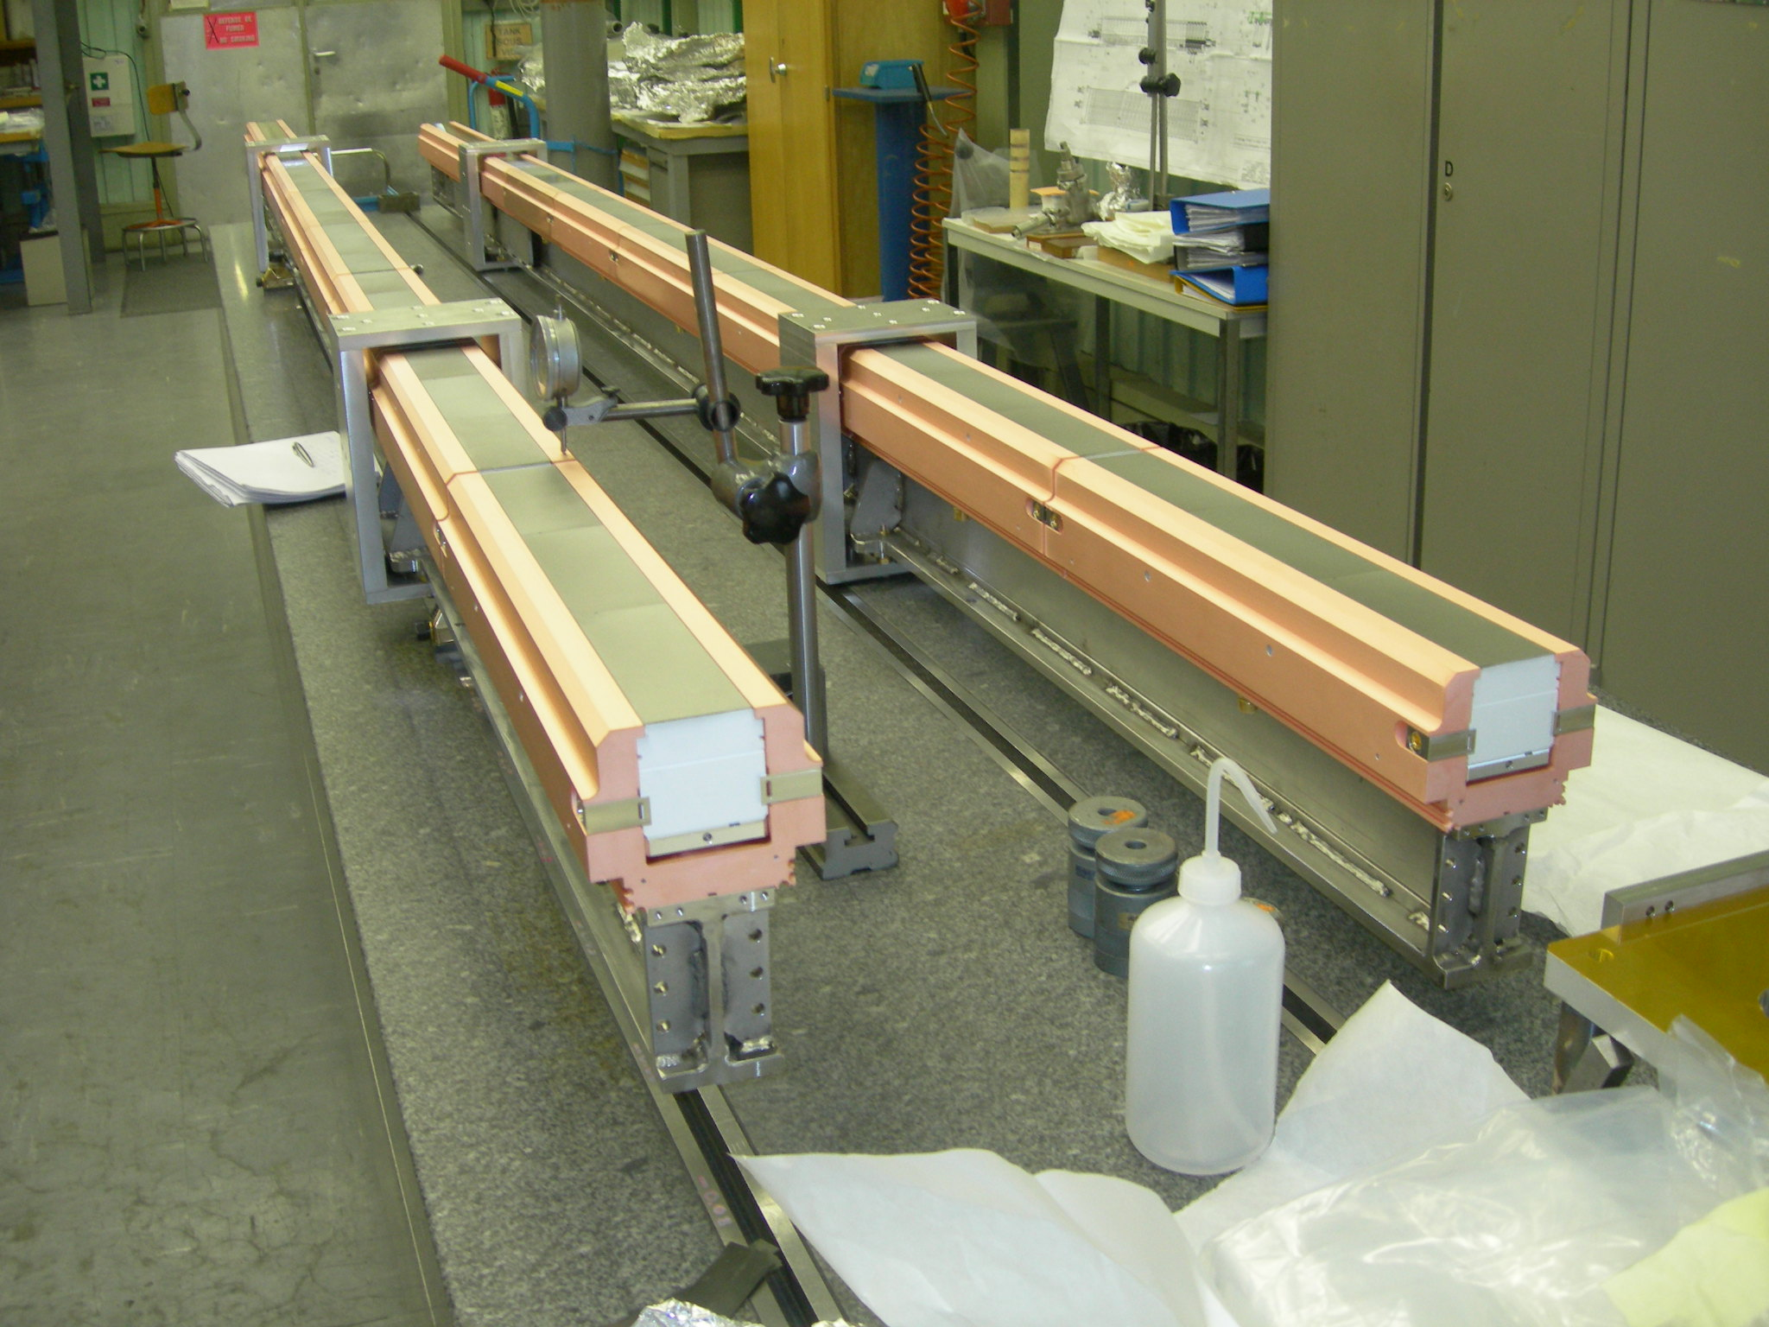 Fig. 4: DSCN0180.

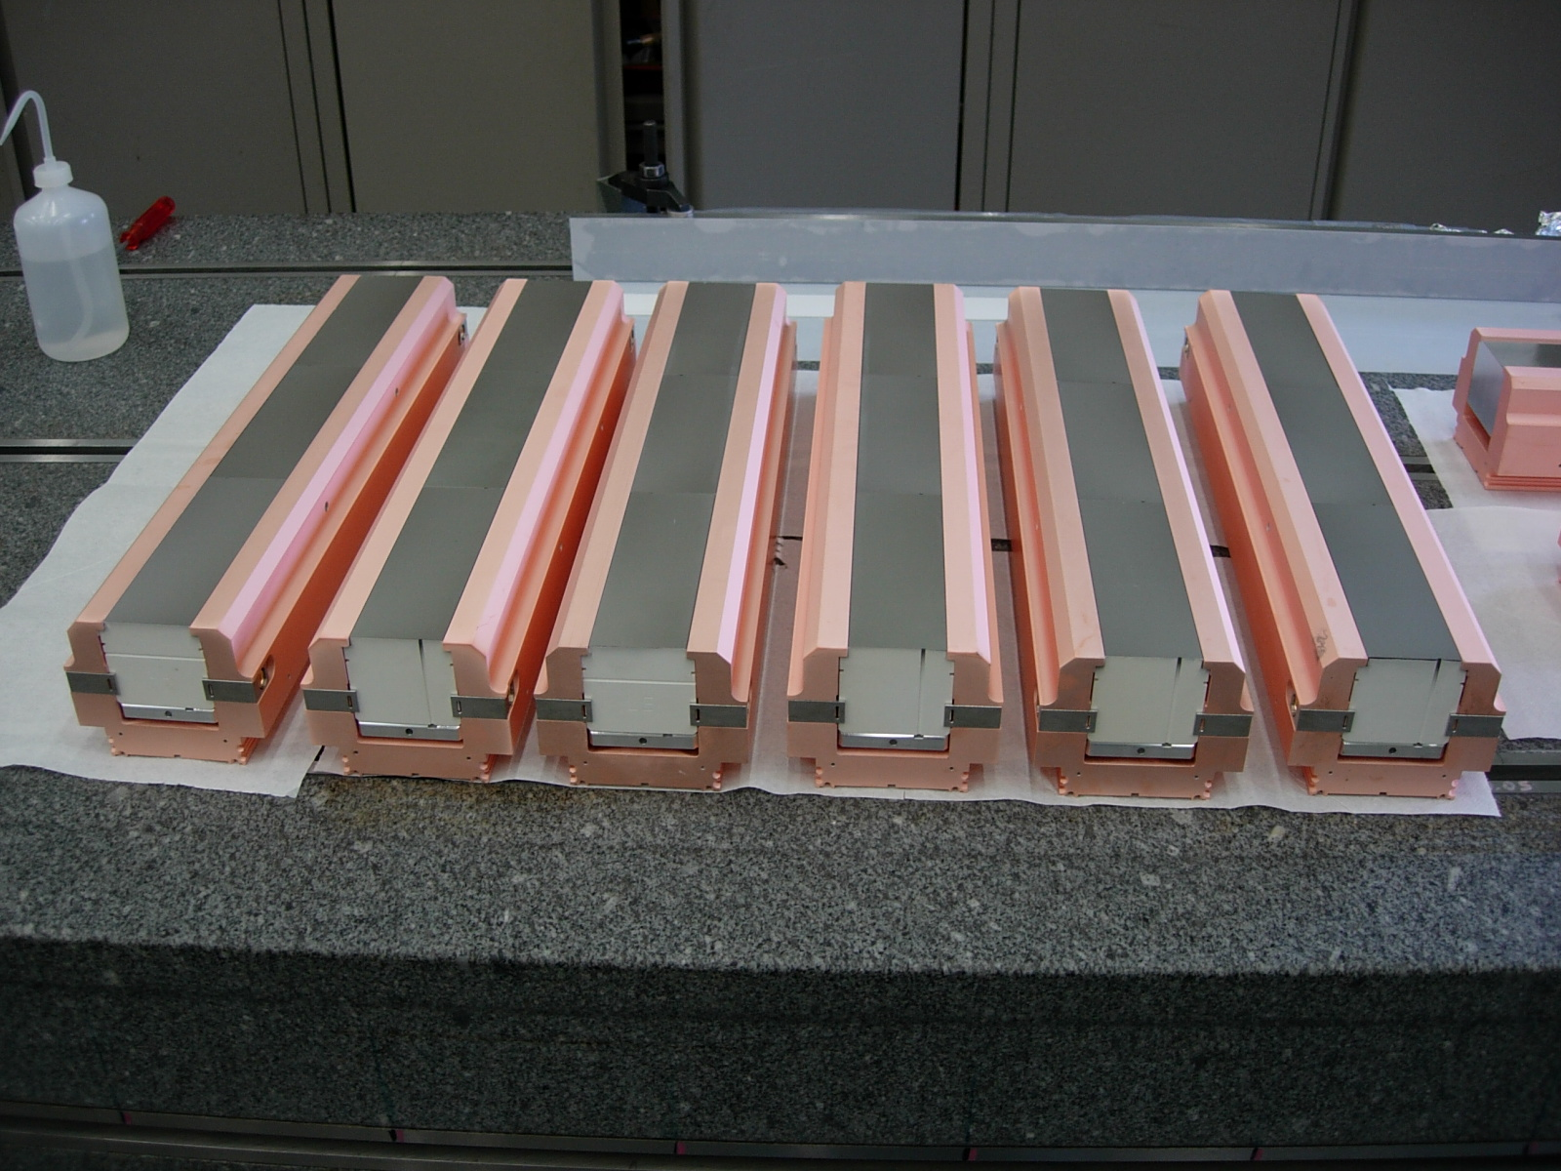 Fig. 5: 6Bnaxial.

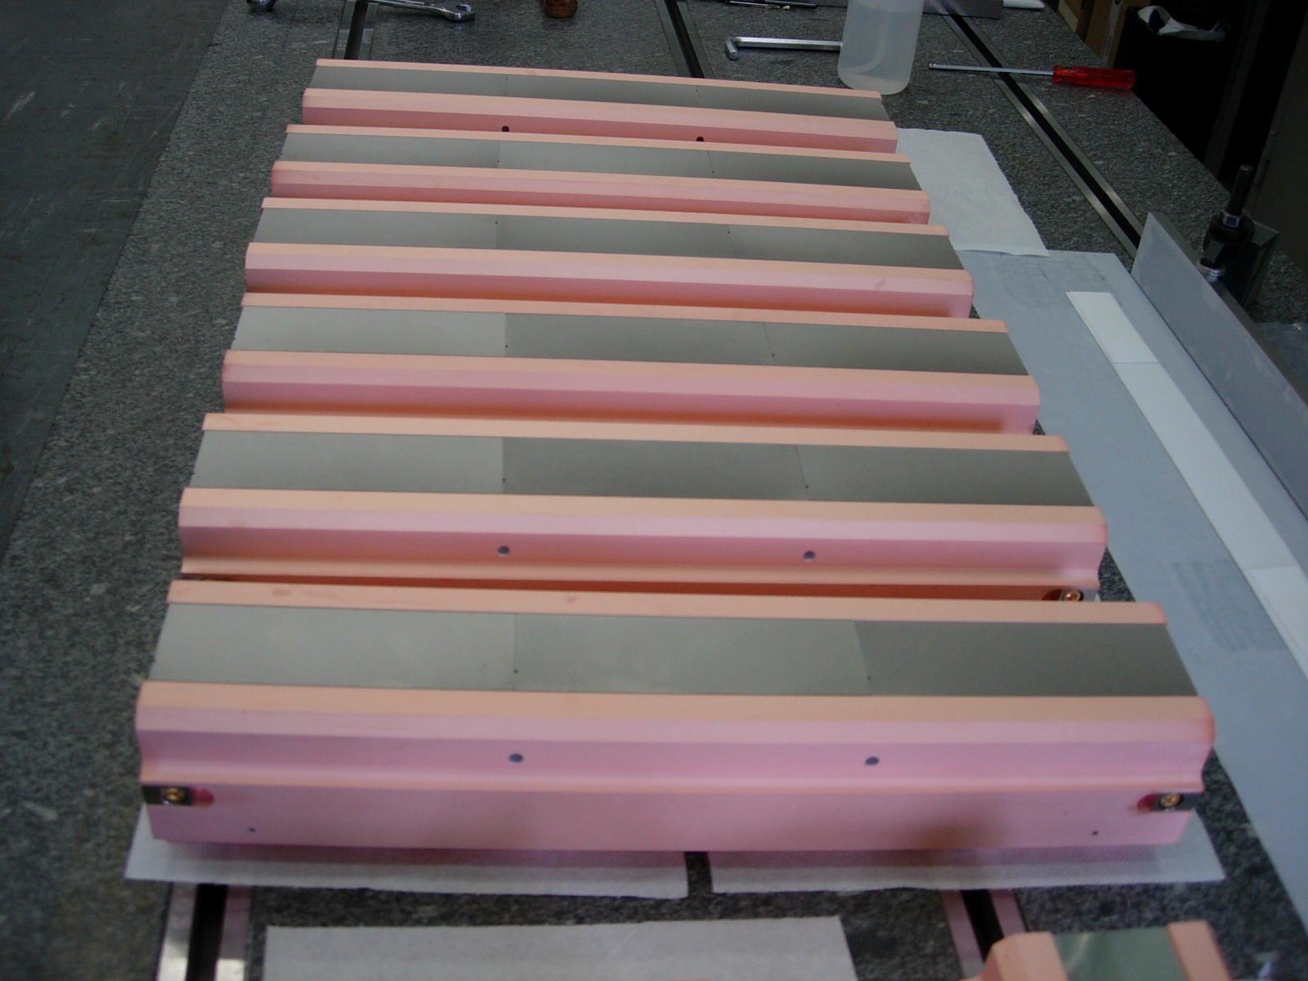
Fig. 6: 6Bnside.
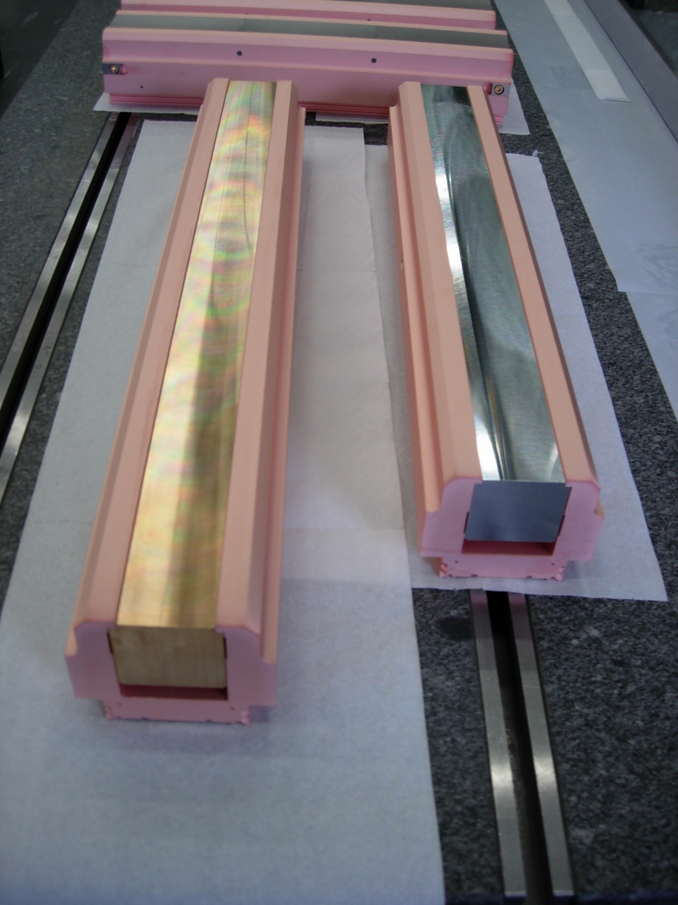Fig. 7: CU + AL.

